Week11

**Q1)**Twostrings***A***and***B***comprisingoflowercaseEnglishlettersarecompatibleiftheyareequalor can be made equal by following this step any number of times:

· Selectaprefixfromthestring ***A***(possiblyempty),andincreasethealphabeticalvalueofallthe characters inthe prefix by the same validamount.For example,if thestring is ***xyz***andwe selectthe prefix ***xy*** then we can convert it to ***yx*** by increasing the alphabetical value by 1. But if we select the prefix ***xyz*** then we cannot increase the alphabetical value.

Yourtaskistodetermineifgivenstrings***A***and***B***arecompatible.

## Inputformat

Firstline:String ***A***

Nextline:String***B***

## Outputformat

Foreachtestcase,print ***YES***ifstring***A***canbeconvertedtostring***B***,otherwiseprint***NO***.

## Constraints

***1≤ len(A) ≤1000000***

***1≤ len(B)≤ 1000000***

# SAMPLEINPUT

abaca cdbda

# SAMPLEOUTPUT

YES

## Explanation

Thestring ***abaca***canbeconvertedto***bcbda***inonemoveandto***cdbda***inthenextmove.

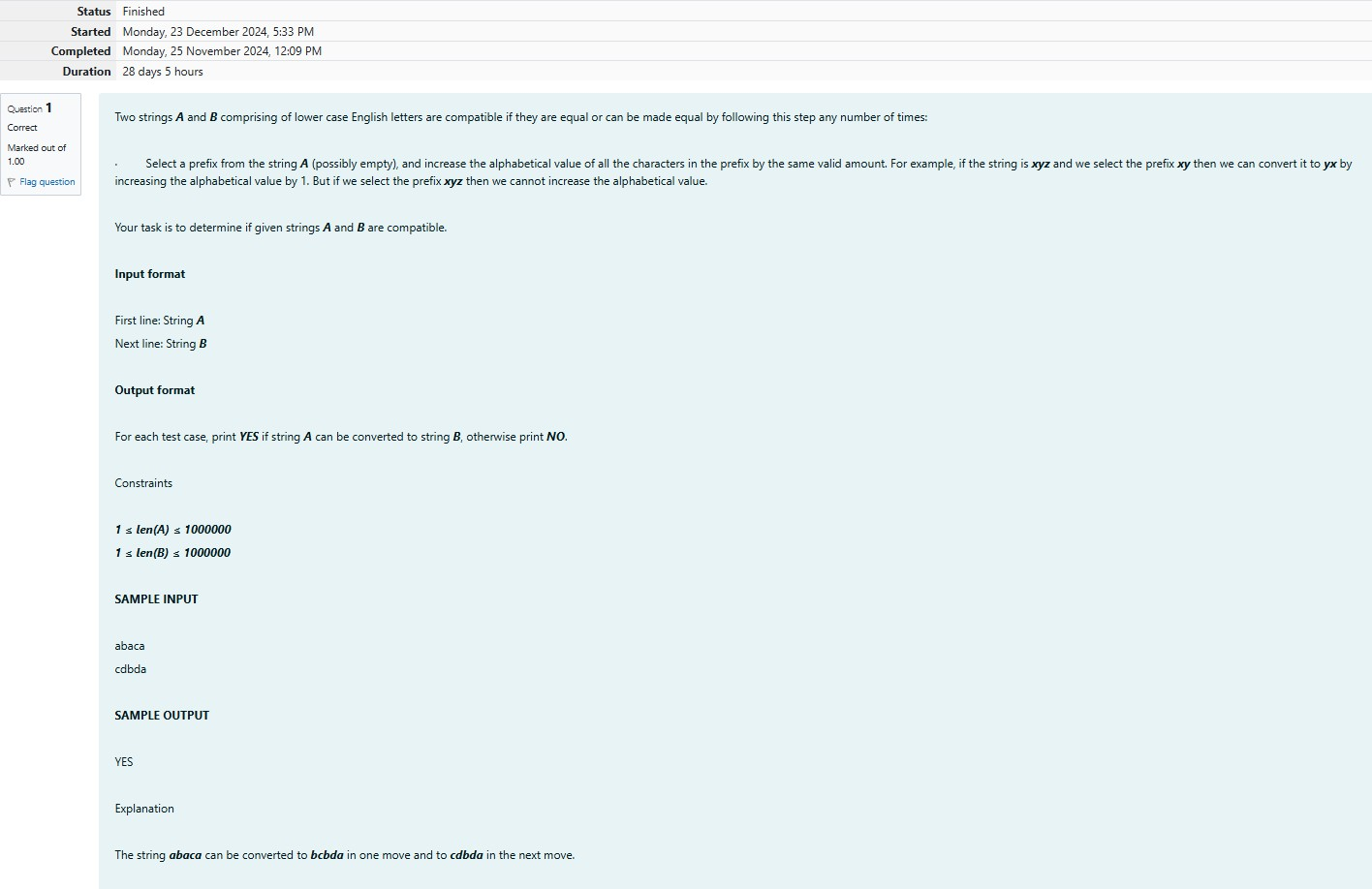

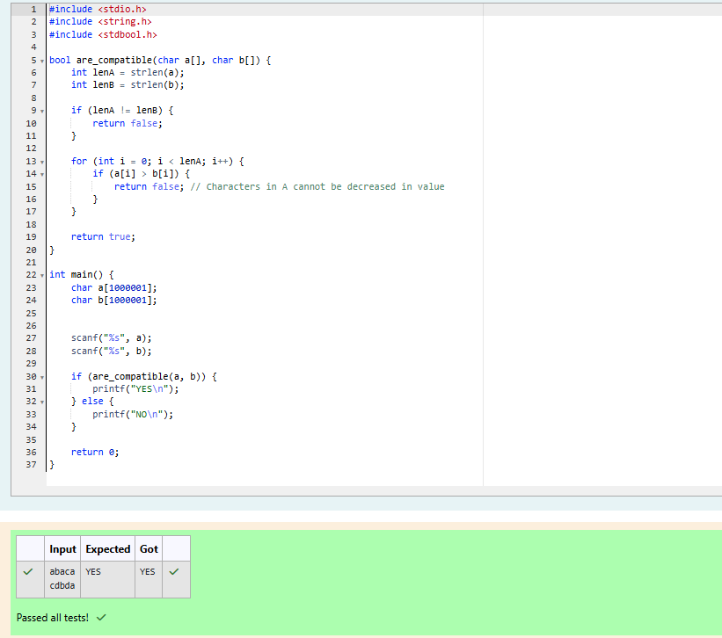

**Q2)** Danny has a possible list of passwords of Manny's facebook account. All passwords length is odd.ButDannyknowsthatMannyisabigfanofpalindromes.So,hispasswordandreverseofhis password both should be in the list.

YouhavetoprintthelengthofManny'spasswordandit'smiddlecharacter.

**Note:Thesolutionwillbeunique.**

# INPUT

ThefirstlineofinputcontainstheintegerN,thenumberofpossiblepasswords.

EachofthefollowingNlinescontainsasingleword,itslengthbeinganoddnumbergreaterthan2 and lesser than ***14***. All characters are lowercase letters of the English alphabet.

# OUTPUT

Thefirstandonlylineofoutputmustcontainthelengthofthecorrectpasswordanditscentrallet- ter.

**CONSTRAINTS *1 ≤ N ≤ 100* SAMPLEINPUT**

4

abc def feg cba

# SAMPLEOUTPUT

3b

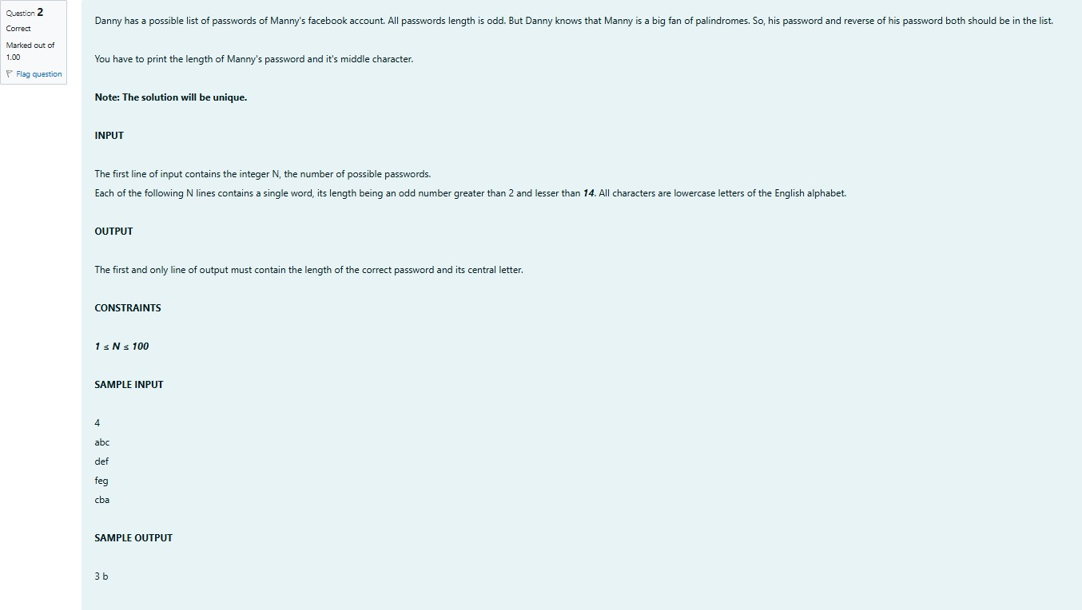

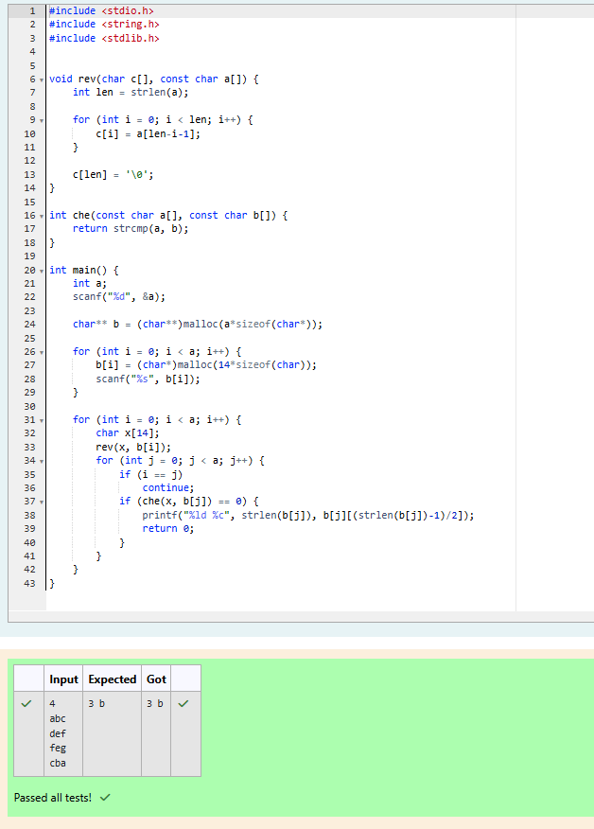

**Q3)**Joey lovestoeatPizza.Butheisworriedasthequalityof pizza madebymostof therestau- rantsisdeteriorating.Thelastfewpizzasorderedbyhimdidnottastegood:(.Joeyisfeelingex- tremely hungry and wants to eat pizza. But he is confused about the restaurant from where he should order. As always he asks Chandler for help.

ChandlersuggeststhatJoeyshouldgiveeachrestaurantsomepoints,andthenchoosetherestau- rant having **maximum points**. If more than one restaurant has same points, Joey can choose the one with **lexicographically smallest** name.

Joeyhasassignedpointstoalltherestaurants,butcan'tfigureoutwhichrestaurantsatisfiesChan- dler's criteria. Can you help him out?

## Input:

FirstlinehasN,thetotalnumberof restaurants.

NextNlinescontainNameofRestaurantandPointsawardedbyJoey,separatedbyaspace.Restau- rant name has **no spaces**, all lowercase letters and will not be more than 20 characters.

## Output:

PrintthenameoftherestaurantthatJoeyshouldchoose.

## Constraints:

1<=N<=105

1<=Points<=106

# SAMPLEINPUT

3

Pizzeria108

Dominos145

Pizzapizza 49

# SAMPLEOUTPUT

Dominos

## Explanation

**Dominos**hasmaximumpoints.

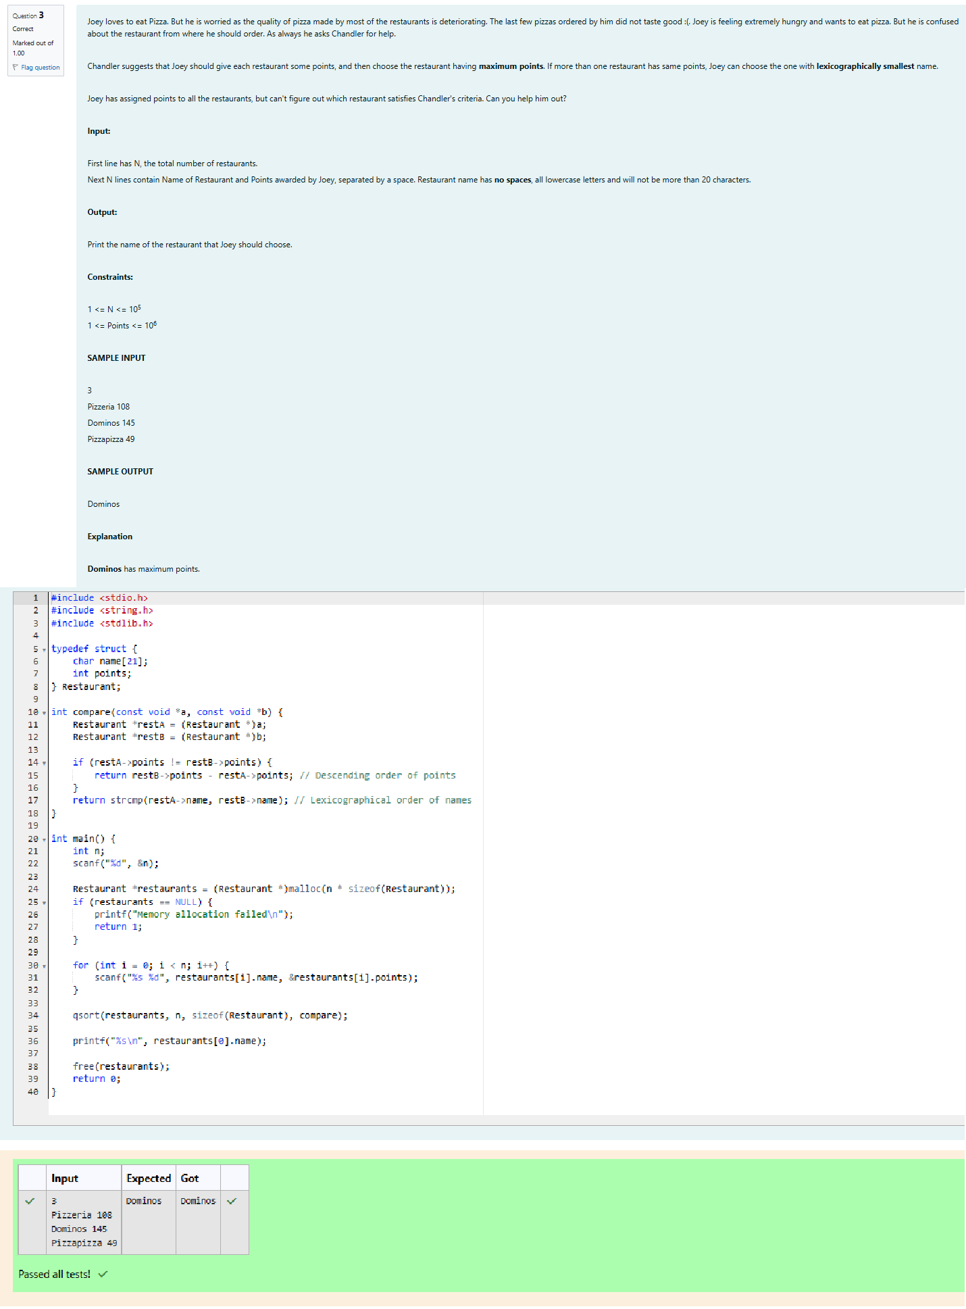

**Q4)**ThesedaysBechanChachaisdepressedbecausehiscrushgavehimlistofmobilenumbersome of them are valid and some of them are invalid. Bechan Chacha has special power that he can pick his crush number only if he has valid set of mobile numbers. Help him to determine the valid num- bers.

Youaregivenastring"S"andyouhavetodeterminewhetheritisValidmobilenumberornot.Mo- bile number is valid only if itis of length 10, consistsof numericvalues and it shouldn't have prefix zeroes.

## Input:

FirstlineofinputisTrepresentingtotalnumberoftestcases.

NextTlineeachrepresenting"S"asdescribedininproblemstatement.

## Output:

Print"YES"ifitisvalidmobilenumberelseprint"NO". Note: Quotes are for clarity.

## Constraints:

1<=T<= 103

sumofstringlength<=105

# SAMPLEINPUT

3

1234567890

0123456789

0123456.87

# SAMPLEOUTPUT

YES NO NO

